Writing for strings and the String Quartet

Instruments and Ranges

Violin
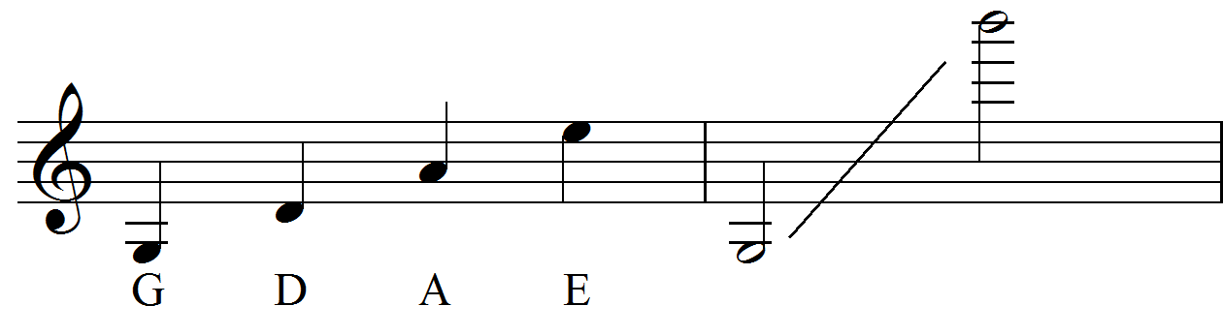
Cello
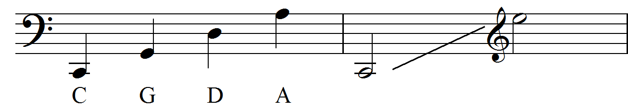

Viola
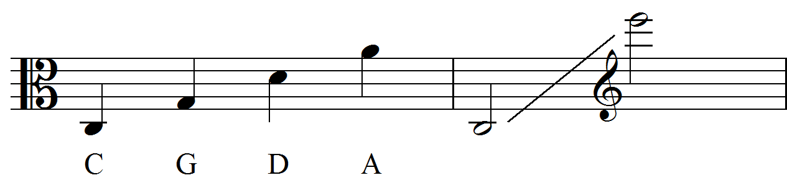

Bowing Techniques
Term | Abbreviation in the score | What it means
Arco | arco | Play using the bow
Pizzicato | pizz | Pluck the strings
Slur | ͡ or ͜ | Do not change bow
Col Legno | col leg. (c.l.) | With the wood of the bow
Sul ponticello | sul pont. (s.p.) | Near the bridge
Sul tasto | sul tasto (s.t.) | Near the fingerboard (normally understood as ‘on’ the fingerboard)
Tremolo | trem. | Fast unmeasured bow changes
Legato | legato | Smooth and without silence between notes
Spiccato | spicc. | Bow leaves the string to produce a light bouncing sound
Jeté/Ricochet | Jeté | Bow is ‘thrown’ at the string to produce a rapid series of notes, normally unspecified and unmeasured
Bartok/snap Pizzicato | [a circle with a line | String is pulled away from the fingerboard, so that it snaps against in on release
Left hand pizz | L.H. pizz or + | String plucked with LH, best with open strings

Harmonics
Natural Harmonics
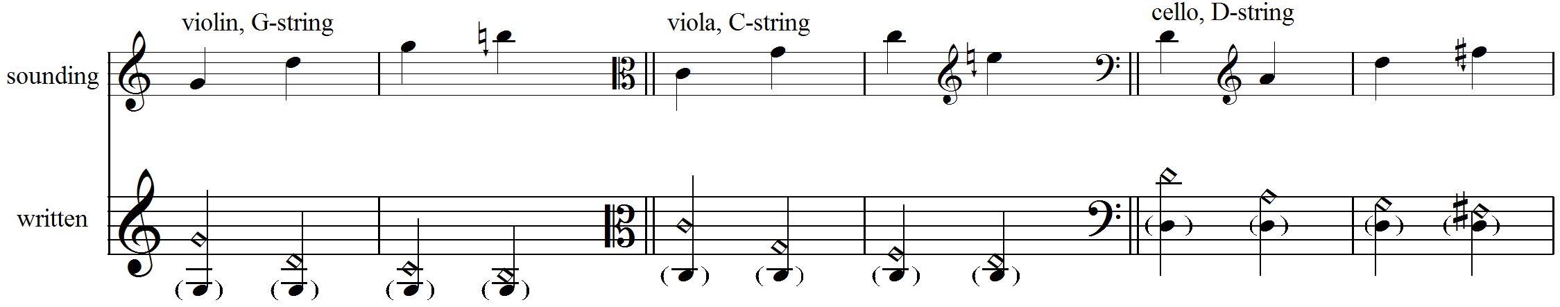
‘False’ Harmonics
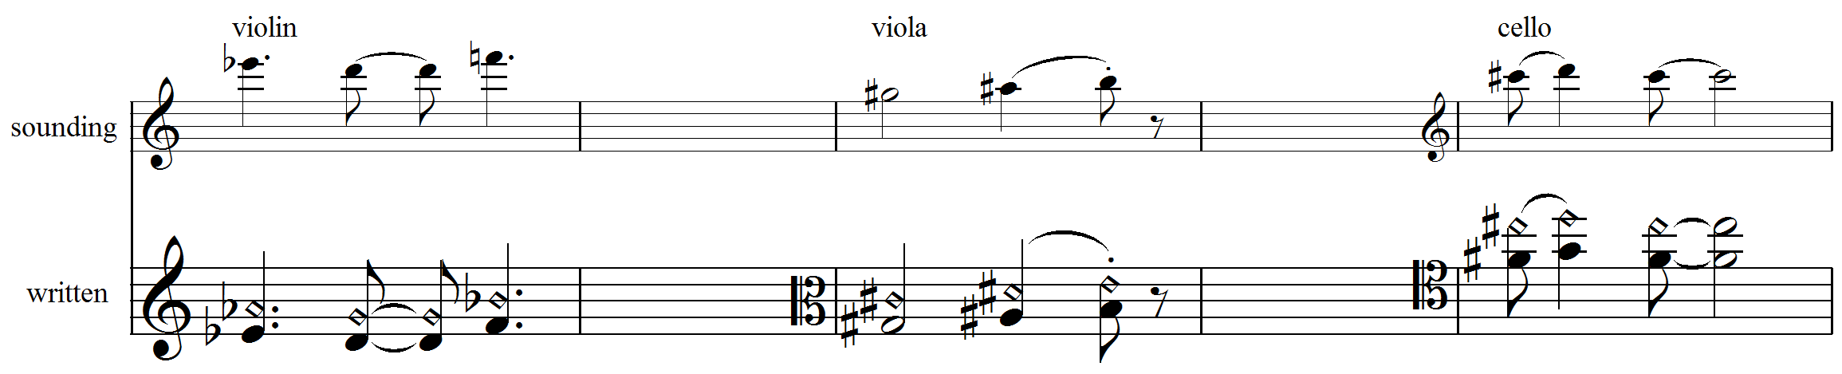
Listening List
The string quartet is a very standard line-up since it was first used by Haydn. The string trio (two violins and a cello, or violin, viola cello) is also a standard instrumentation, and there are many examples of duets for
Pre-1950s Joseph Haydn – String Quartet Op. 54, No. 2
Ludwig van Beethoven – String Quartet, Op. 131 in C sharp minor
Maurice Ravel – String Quartet in F major
Antonín Dvořák – No. 12 in F major, Op.96
Claude Debussy – String Quartet in G minor
Bela Bartok – String Quartet No. 6
Anton Webern – Five Pieces for String Quartet (Op. 5)

Post 1950s Dimitri Schostakovich – String Quartet No. 8
Thomas Adés – Arcadiana
Jonathon Harvey – String Quartet No. 1
György Ligeti – String Quartet No. 2
Henri Dutilleux – Ainsi la Nuit
György Kurtág – 12 microludes for String Quartet
Steve Reich – Different Trains

